Challenge
LO5 – Manage & Control
Malamski,Dimitar D.S.
mitemalamata@gmail.com

Contents
Contents 1
Introduction 2
Sprints 2
Sprint 4 2
Evidence 1 - Documenting the Full Development Process 2
Evidence 2 - Making the Dataset Transferable with Dataset Documentation 3
Evidence 3 - Saving Experiment Results for Reproducibility 4
Evidence 4 - Adding Confidence Safeguards for Transparent Recommendations 4
Sprint 3 5
Evidence 1 - Defining dataset rules and labeling guidelines 5
Evidence 2 - Ensuring reproducibility through controlled randomness 6
Sprint 1 & 2 7

Introduction
This document presents the evidence for Learning Outcome 5 ( Manage & Control ) in my Challenge project – Outfit Recommendation System. The purpose of this document is to show how I demonstrated this learning outcome by making the AI solution transparent, interpretable, explainable, and transferable within its context. The evidence is organized by sprint, with each section describing the activity, the result, and why it is relevant to the learning outcome.

Sprints

Sprint 4

Evidence 1 - Documenting the Full Development Process
What this evidence is
This evidence is the development summary document, where I documented the main experiments, results, decisions, and next steps of the project.
What I did
During the project, I kept track of how the system developed from the first classification baselines into the recommendation prototype. I documented the purpose of each experiment, the results, the main conclusions, and why certain decisions were made. I also described which models are currently selected for the prototype and what limitations still remain.
Result
This resulted in one clear overview of the full development process. The document makes it easier to understand how the project evolved and why the current solution was chosen.
Why this is relevant to the Learning Outcome
This demonstrates Manage & Control because the development process is documented in a transferable way. Someone else can follow the experiments, understand the decisions, and continue the project or repeat the process more easily.
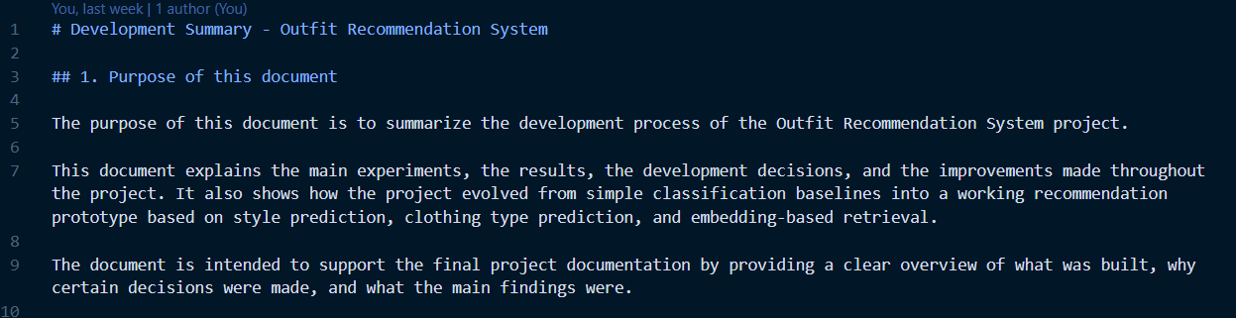

Evidence 2 - Making the Dataset Transferable with Dataset Documentation
What this evidence is
This evidence is the dataset documentation, where I explained how the dataset is structured and how it should be used.
What I did
I documented the dataset folders, such as raw, cleaned, metadata, split folders, real-world test data, and extra training data. I also explained the meaning of the style and clothing type labels, and how the data is organized for training, testing, and evaluation.
Result
This resulted in a dataset that is easier to understand and reuse. The documentation makes clear where the data is stored, what each folder is used for, and how the dataset supports the different experiments.
Why this is relevant to the Learning Outcome
This demonstrates Manage & Control because it makes the dataset transferable within the project context. The dataset is not only present in the repository, but also explained in a way that allows future work or further research to continue from it.
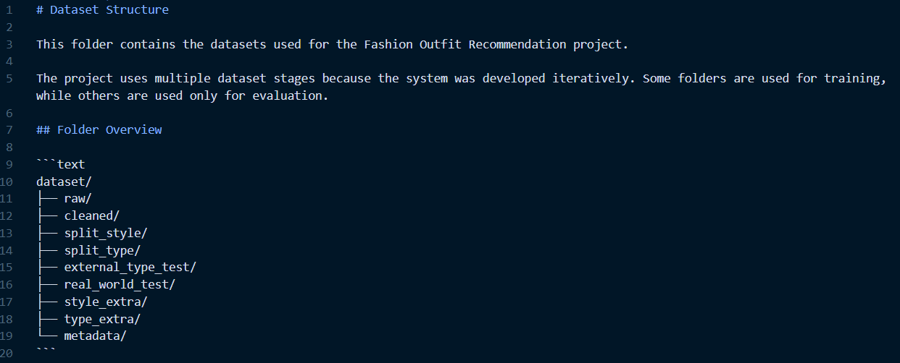
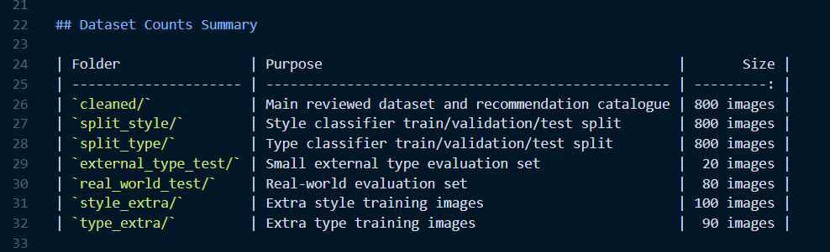

Evidence 3 - Saving Experiment Results for Reproducibility
What this evidence is
This evidence shows how I saved the results of the experiments in separate result files instead of only keeping them inside the notebooks.
What I did
For the experiments, I saved outputs such as model summaries, classification reports, confusion matrices, training history files, recommendation evaluation results, catalogue indexes, and experiment summaries. These files were stored in the results folder so they can be checked again later.
Result
This resulted in a more reproducible project. The results can be reviewed, compared, and reused without needing to rerun every notebook from the beginning. It also makes it easier to compare different experiments and understand which version performed better.
Why this is relevant to the Learning Outcome
This demonstrates Manage & Control because it improves transparency and reproducibility. The process from input data to model results is documented through saved outputs, making the project easier to verify and continue.
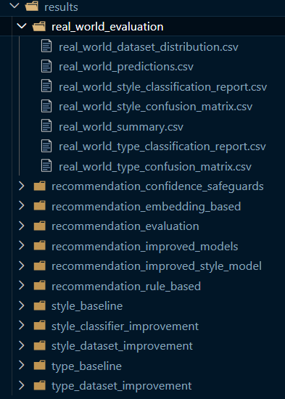

Evidence 4 - Adding Confidence Safeguards for Transparent Recommendations
What this evidence is
This evidence shows how I added confidence safeguards to make the recommendation output more transparent.
What I did
After testing the recommendation system, I noticed that wrong style or clothing type predictions could lead to weak recommendations. Because of this, I added confidence checks for both predictions using a threshold of 0.60. Based on the confidence scores, the system marks the recommendation as reliable, type uncertain, style uncertain, or both style and type uncertain.
Result
The result was a recommendation output that is easier to understand. In the tested real-world examples, 4 recommendations were marked as reliable, 2 as type uncertain, and 2 as style uncertain. This helped show when the system output should be trusted and when it should be treated with caution.
Why this is relevant to the Learning Outcome
This demonstrates Manage & Control because it improves the transparency and interpretability of the AI solution. The system does not only give a recommendation, but also explains whether the prediction behind it is reliable or uncertain.

Sprint 3

Evidence 1 - Defining dataset rules and labeling guidelines
What this evidence is
This evidence shows how I ensured consistency and transparency in the dataset by defining clear labeling rules and guidelines.
What I did
Since the dataset was manually curated, I created a dedicated document ( dataset_rules.md ) that defines the meaning of each style class and the rules for assigning labels. These rules describe how to distinguish between styles such as gothic, formal, sporty, and streetwear, and how to handle ambiguous cases. During data collection, I followed these rules to ensure that each image was labeled consistently and that unclear or borderline examples were avoided.
Result
This resulted in a more consistent and reliable dataset with reduced ambiguity between classes. It also created a clear reference that documents how the dataset was constructed, making the process easier to understand and reproduce.
Why this is relevant to the Learning Outcome
This demonstrates manage and control because I ensured that the dataset creation process is transparent and governed by clear rules. This improves both the interpretability of the model and the reliability of the results.
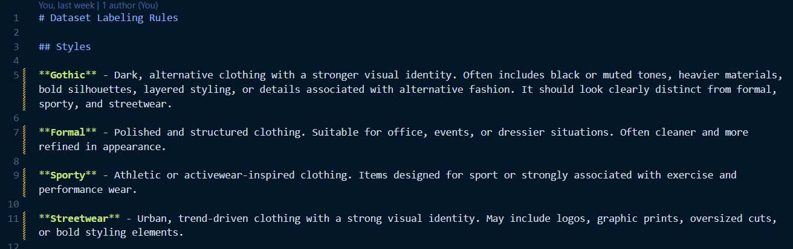
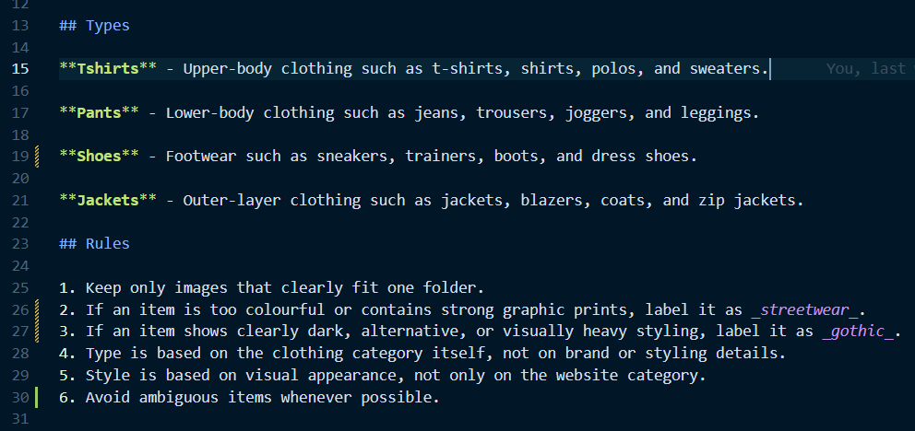

Evidence 2 - Ensuring reproducibility through controlled randomness
What this evidence is
This evidence shows how I ensured that the machine learning experiments can be reproduced consistently.
What I did
I set fixed random seeds for all relevant libraries, including Python’s random module, NumPy, and PyTorch. I also ensured that the same dataset splits and training conditions were used across experiments. This reduces variability caused by randomness and ensures that the results can be reproduced under the same conditions.
Result
This resulted in a more stable and consistent experimental setup. Running the same code multiple times produces comparable results, which improves the reliability and trustworthiness of the model evaluation.
Why this is relevant to the Learning Outcome
This demonstrates manage and control because I implemented mechanisms to control randomness and ensure reproducibility. This makes the experiments more transparent and allows others to verify and build upon the results.
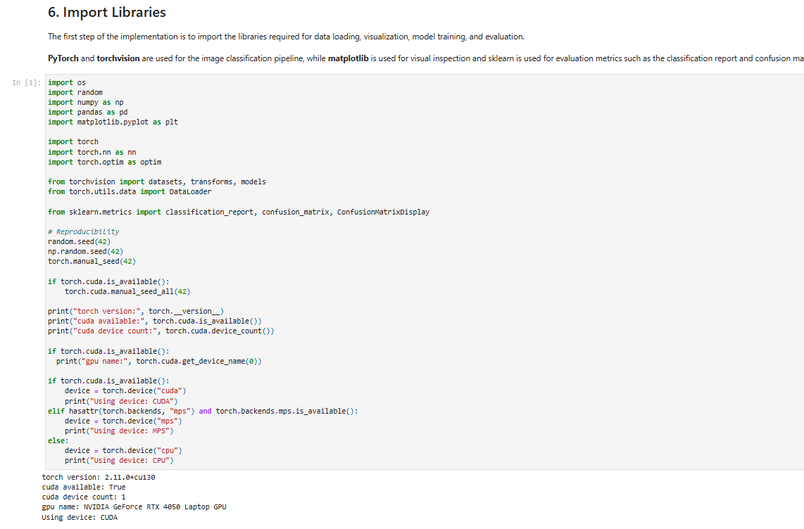

Sprint 1 & 2
There was no work done in those sprints, since the projects starts from Sprint 3.

